ECON 205
Prof. Dr. Dilek Temiz
WORKSHEET 1

1. Find the equilibrium price and quantity in a market whose supply and demand curves are given by
P = 4Q^{s} and P = 12 -2Q^{d}, respectively.

2.The market for DVDs has supply and demand curves given by Qs=P/2 and Qd= 42-P, respectively.
a. How many units will be traded at a price of €35? At a price of €14? Which participants will be dissatisfied at these prices?
b. What quantity of DVDs at what price will be sold in equilibrium?
c. What is the total revenue from DVD sales?

3.Suppose a newly released study shows that battery-powered toys harm a child’s development and recommends that parents adjust their purchasing behavior accordingly. Use diagrams to show the effect on price and quantity in each of the following markets:
a. The market for battery-powered toys.
b. The market for batteries.
c. The market for yo-yos (which do not require batteries).

4.Using diagrams, show what changes in price and quantity would be expected in the following markets under the scenarios given:
a. Crude oil: As petroleum reserves decrease, it becomes more difficult to find and recover crude oil.
b. Air travel: Worries about air safety cause travellers to shy away from air travel.
c. Rail travel: Worries about air safety cause travellers to shy away from air travel.
d. Hotel rooms in Majorca: Worries about air safety cause travellers to shy away from air travel.
e. Milk: A genetically engineered hormone enables large milk producers to cut production costs.

5. Suppose demand for seats at football games is P = 1900 - (1/50) Q and supply is fixed at Q = 90,000 seats.
a. Find the equilibrium price and quantity of seats for a football game (using algebra and a graph).
b. Suppose the government prohibits tickets scalping (selling tickets above their face value), and the face value of tickets is €50 (this policy places a price ceiling at €50). How many consumers will be dissatisfied (how large is excess demand)?
c. Suppose the next game is a major rivalry, and so demand jumps to P = 2100 - (1/50) Q. How many consumers will be dissatisfied for the big game?

6.The demand for apartments is P = 1200 - Q while the supply is P = Q units. The government imposes rent control at P = €300/month. Suppose demand grows in the market to P = 1400 - Q.
a. How is excess demand affected by the growth in demand for apartments?
b. At what price would the government have to set the rent control to keep excess demand at the same level as prior to the growth in demand?

7.Suppose demand is P = 600 - Q and supply is P = Q in the wheat market, where Q is tons of wheat per year. The EU sets a price support at P = €500/ton and purchases any excess supply at this price. In response, as a long-run adjustment, farmers switch their crops from corn to wheat, expanding supply to P = (1/2) Q.
a. How does excess supply with the larger supply compare to excess supply prior to the farmers switching crops?
b. How much more does the EU have to spend to buy up the excess supply?

8.How would the equilibrium price and quantity change in the market depicted below if the marginal cost of every producer were to increase by €2/kilogram?
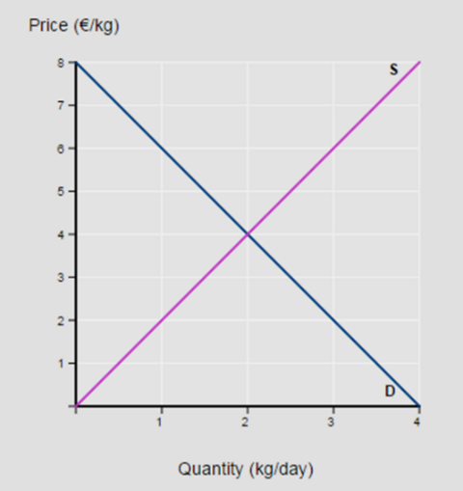

9. Fill in the accompanying table, showing whether equilibrium price and equilibrium quantity go up, down or stay the same, or is indeterminate.
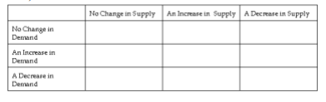
10. Suppose that the number of buyers in a market increase and a technological advancement occurs also. What would we expect to happen in the market?
11. Suppose you like banana cream pie made with vanilla pudding. Assuming all other things are constant, you notice that the price of bananas is higher. How would your demand for vanilla pudding be affected by this?

12. Assume that both the demand curve and the supply curve for DVD players shift to the left but the demand curve shifts more than the supply curve. What would we expect to happen in the market?

13. Qd = 60 - 3P, Qs = - 40 + 5P
a. Calculate the quantity demanded if the price is 6.
b. Calculate the quantity supplied if the price is 12.
c. Calculate the market equilibrium (P and Q).
d. Rearrange the demand and supply function to obtain inverse functions: (P = ...)
e. Graph this market (x-axis: Q / y-axis: P).

14. Q_{d} = 8 – P, Q_{s} = - 4 + P². Calculate the market equilibrium.

15. Sales figures show that your company sold 1960 pen sets each week when they were priced at $1/pen set, and 1800 pen sets each week when they were priced at $5/pen set. What is the linear demand function for your pen sets?

16. Find the equilibrium price and quantity in the market if demand function is; 𝑸𝒅 =63-3P and supply function is; 𝑸𝒔 =4P. Where, 𝑸𝒅 is quantity demanded, 𝑸𝒔 is quantity supplied and P is price.

17. If the market consists of three consumers; J, K and L with their individual demand functions as;
P= 35-0.50𝑸𝑱 , P= 50-0.250𝑸𝑲 and P= 40-2.0𝑸𝑳. The market supply function is given as 𝑸𝑺= -40+3.5P. Determine the market equilibrium price and quantity. Also find individuals demand at equilibrium price.

18. Suppose there are 100 identical consumers in the market for the commodity X, each with demand function 𝑸𝒅𝒙=190-5𝑷𝒙 and 50 identical producers of the commodity X, each with a supply function given by 𝑸𝒔𝒙=20+2𝑷𝒙. Find the market demand and market supply function and determine the equilibrium price and equilibrium quantity in the market. What happens if the government grants per unit cash subsidy to all the producers of commodity X?

19. From a demand function 𝑸𝒅=2,000-30P and a supply function 𝑸𝒔=20P, find out equilibrium price, equilibrium quantity and gap between demand and supply at price of 50.

20. If the demand and supply functions are given as below; 𝑸𝒅=100-5P and 𝑸𝒔=10+5P. Determine the equilibrium price and quantity. If there is increase in consumer’s income and so that new market demand becomes 𝑸′𝒅=200-5P then determine new equilibrium price and quantities.

21. If you are given the following demand schedule.

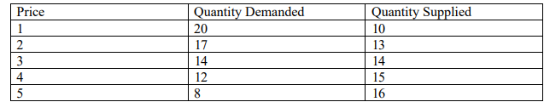
Find the equilibrium price and quantities. If the quantity demanded at each price is increased by 3 units, then what would be the new equilibrium price and quantity?

22. Suppose there are 1000 identical individuals in the market for a particular commodity each with a demand function 𝑸𝒅=12-2P and 1000 identical suppliers each with a function given by 𝑸𝒔=2P. Find the market demand function and market supply function. Calculate the value of economic variables at the point of equilibrium. Again, suppose there is an improvement in the technology of producing unit so that a new market supply curve is given by 𝑸′𝒔=4000+2000P. State the new equilibrium price and the new equilibrium quantity of the goods.
23. Suppose the demand and supply functions are given as below; (𝐐𝐝)=1000-2P, and supply function is (𝐐𝐬)= -100+8P. Where 𝐐𝐝 is quantity demanded, 𝐐𝐬 is quantity supplied and P is price. Find the equilibrium price and quantity. If government imposes price ceiling of $80, what are quantity demanded and supplied. What does it imply?

24. Suppose the demand and supply functions are given as below; (𝐐𝐝)=1000-2P, and supply function is (𝐐𝐬)= -100+8P. where 𝐐𝐝 is quantity demanded, 𝐐𝐬 is quantity supplied and P is price. Find the equilibrium price and quantity. If government imposes price floor of Rs.120, what are quantity demanded and supplied. What does it imply?

25. The demand curve for product X is given as Q = 1500 – 50P. Write the equations for total revenue and average revenue.

26. Consider the following demand and supply curves for a certain product: Qd = 30 – 3P; Qs = -10 + 2P. Determine the equilibrium price and quantity. Suppose the supply shifts to Qs = -5 + 2P, with no change in demand. Determine the new equilibrium price and quantity. Use the graph, confirm your answer.
27. Graph x
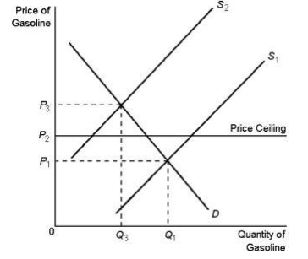
According to Graph x, when the supply curve for gasoline shifts from S1 to S2
a. the price will increase to P3.
b. a surplus will occur at the new market price of P2.
c. the market price will stay at P1 due to the price ceiling.
d. a shortage will occur at the price ceiling of P2.

28. Graph y
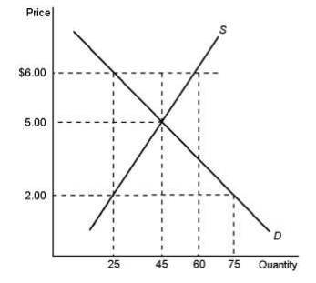
According to Graph y, a binding price floor would exist at a price of
a. $6.00.
b. $5.00.
c. $2.00.
d. $25.0.

29. Consider the following demand and supply curves for a certain product: P = 1000 – 0,05Q; P = 100+ 0,1Q Determine the equilibrium price and quantity. Compute CS, PS and TS. Draw the related figure.

30. Suppose the government decides a levy a $200 per gallon tax on the sellers of gasoline.
P= 2000 – 10Q P = 40Q
a) What are the equilibrium price and quantity after the tax?
b) How much money goes to government?
c) What is the tax burden for consumer?
d) What is the tax burden for seller?

31. Consider the following demand and supply curves for a certain product:
Qd = 28 – 3P; Qs = -12 + 2P. Determine the equilibrium price and quantity. Suppose the supply shifts to Qs = -2 + 2P, with no change in demand. Determine the new equilibrium price and quantity. Use the graph, confirm your answer.
32. Graph z
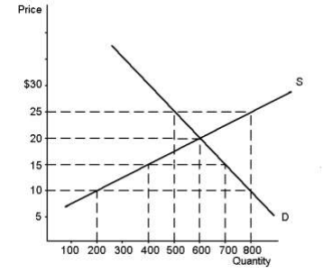
Refer to the Graph z. If price is $15, quantity supplied would be…………..
Refer to the Graph z. At a price of $20………..
Refer to the Graph 4-6. In this market, equilibrium price and quantity would be…….

33.
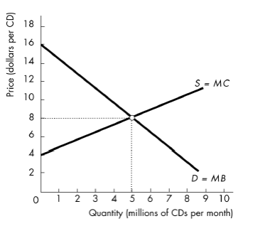

In the figure above, when the price of a CD is $8.00, total producer surplus from all the CDs will be……. At the equilibrium, the total revenue is ……..

34. Suppose that student demand for tickets to a concert is as follows:
Price Quantity Demanded
$2 8000
4 5000
6 2500
8 1500
a. With seating capacity fixed at 5000 seats, would there be either excess demand or excess supply at a ticket price of $6?
b. What ticket price should be set to ensure that all seats are taken (so that there is neither a surplus nor a shortage of seats)?
c. Suppose that a very popular performer is booked, causing the quantity of tickets demanded at each price to double. What is the new equilibrium price?

35. Suppose the government decides a levy a 50 cent per gallon tax on the buyers of gasoline. P= 100-2Qd and P=3Qs What are the equilibrium price and quantity after the tax? What are the consumer price and seller price?

36. Given a total revenue function TR = 100 Q – 0,8 Q²
a. Determine the revenue-maximizing output level.
b. Determine the demand function.
c. Determine the price associated with maximizing revenue.

37. Fill in the following table, drawing new curves on the graphs to aid you. Show the initial effects of the events on each market. For shift of the demand curve (D), shift of the supply curve (S), equilibrium price (P_{e}) and the equilibrium quantity (Q_{e}), use (+) or (-) to show increase or decrease, for no change, use (0). If the effect cannot be determined from the information, use (?).
Market Events D S P_{e} Q_{e}

P S
a. DVD Cost of producing DVD increase

D

Q
P
b. Natural Gas the prices of electricity rise S
stoves

D

Q

P
c. Backpacks Students prefer backpacks for carrying S
school supplies; new materials rise
costs of production.
D

Q

P
d. Automobiles Substantially lower wages S
are paid to autoworkers, autodriver
population increases.
D

Q
38. Assume the following demand and supply functions:
Q_{d} = 20 – 5p, Qs = - 12 + 4p
a. Determine the equilibrium price and quantity.
b. Plot the demand and supply curves on the graph and confirm your answer.
c. Suppose the demand shifts to Q_{d} = 40 - 5p, with no change in supply. Determine the new equilibrium price and quantity. Use the graph and also solve algebraically.
d. Suppose that the price had been held constant at its original level in (b). Would a surplus or shortage emerge, and how large would it be?

39. The supply and demand schedules for the shoe market are given below
P Q_{s} Q_{d}
$10 100 400
20 200 200
30 300 100
40 400 50
a. Draw the figure of demand and supply curves. What are the equilibrium price and quantity?
b. If the price level is $30, what would occur?
c. Suppose the government establishes a price of $30, what would occur?
40. The demand curve for a firm’s product is given by the equation
Q = 30 – 0,5 P
- Specify the firm’s total revenue function.
- Solve for the revenue-maximizing level of output.
- Prove that you have reached a point of revenue maximization.
- Determine the revenue-maximizing price.

41. Assume the following demand and supply functions:
Qd = 12 – 2p, Qs = - 3 + p
a. Determine the equilibrium price and quantity.
b. Plot the demand and supply curves on the graph and confirm your answer.
c. Suppose the government-imposed price ceiling at a price of 4$, what is the amount of deadweight loss?

